**Roadmap Poster Guidance**

As a part of this Home Blood Pressure Monitoring pathway resource pack, there are two PDF posters. One outlines the step-by-step approach for practices who have patients on the pathway, and the other is a reference point for patients who are receiving support via the pathway.

In the top-right of each PDF, there is an invisible box that allows you to upload an image of your practice’s logo, as seen in the screenshot below.

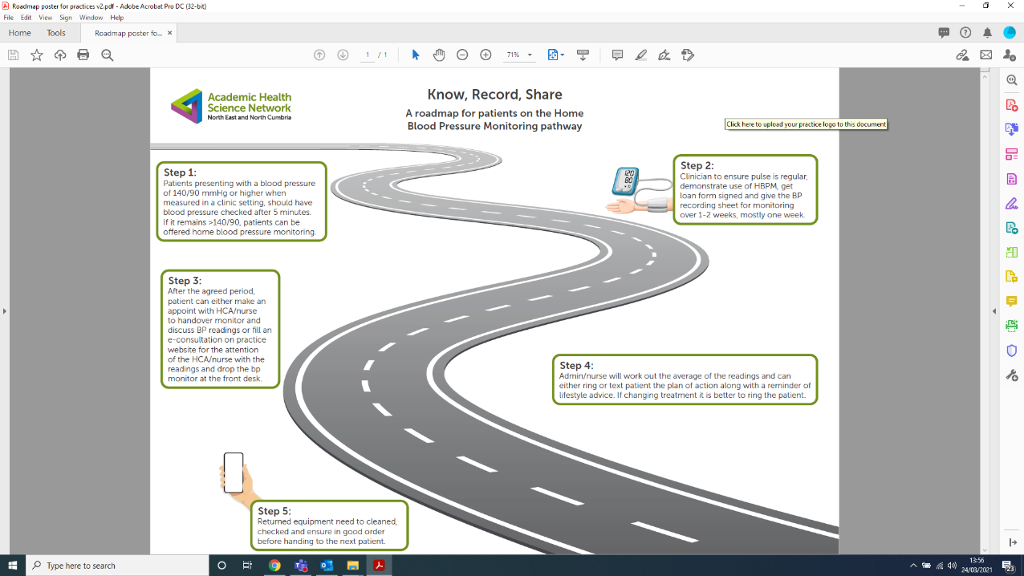

Including your practice’s logo is an important part for any patient-facing document as it improves engagement and consistency with patients when delivering important information.